Task 2:

Create a program that asks for a set of names and will generate an error if the same name is entered twice.

In this program take an array and insert that name. And check if any name reaped then it show a message.

**Working Procedure:**

This program is C# Console program. When I run this program at first it show a message that is asking to take an array size. After taking an array an size it show another message that is asking to take the name. After taking name it checks the duplicate name. If there is any duplicate name then it show an message that is “Here is duplicate name”. If there is no duplicate names then it show “Here is no duplicate name”.

**Algorithm:**

In this program at first take a variable that is define the array size. After define array size then it show insert name. After insert name it check in array string if any name is duplicate or not. If any name duplicate then it increasing er number. And finally it check if er number more than 0 then it show here is duplicate name. if less than 0 then show here is no duplicate name.

**Exception Handling:**

In this program I use try catch for error handling.

**Code:**

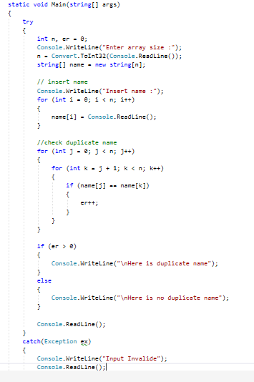

**Output:**

